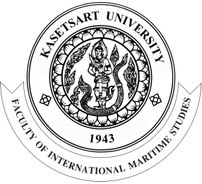 | SEA the Future 2020  https://www.sea-future.com

Abstract template for SEA the Future 2020 conference

First A. Author¹, Second B. Author² and Third C. Author^{1,*}

¹Academic or business affiliation, address, city, zip code, country
²Academic or business affiliation, address, city, zip code, country

Keywords | Abstract
Keyword1  Keyword2  Keyword3  Keyword4  Keyword5  *Corresponding email:  secretary@sea-future.com | International Conference in South East Asia on the Future of Maritime Technology & Use of the Sea (SEA the Future) invites researchers from around the world to submit abstracts for oral presentation at our 2020 meeting in Pattaya, Chonburi, Thailand. The meeting will feature a wide range of exciting talks, discussions, and networking opportunities with experts, researchers, and up-and-coming leaders in the field of maritime technology and use of the sea. To submit your abstract for oral presentation, please use this template and send an email to secretary@sea-future.com. The abstract should not exceed one page and at least 3 keywords are required. The accepted abstract will be published in the “Book of Abstracts” of SEA the Future 2020 conference. Participants can also submit a full paper manuscript instead of an abstract. After a peer-review process, the accepted full paper will be published in Maritime Technology and Research (MTR) which is a journal indexed in Crossref and Google Scholar.

